Problem 1: Write a java program that takes an user input array and display its elements.

Code:

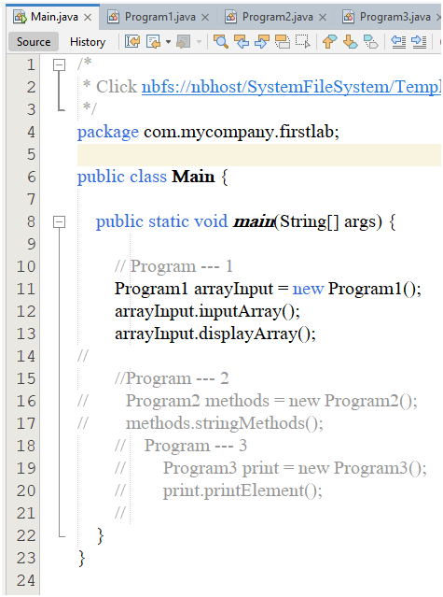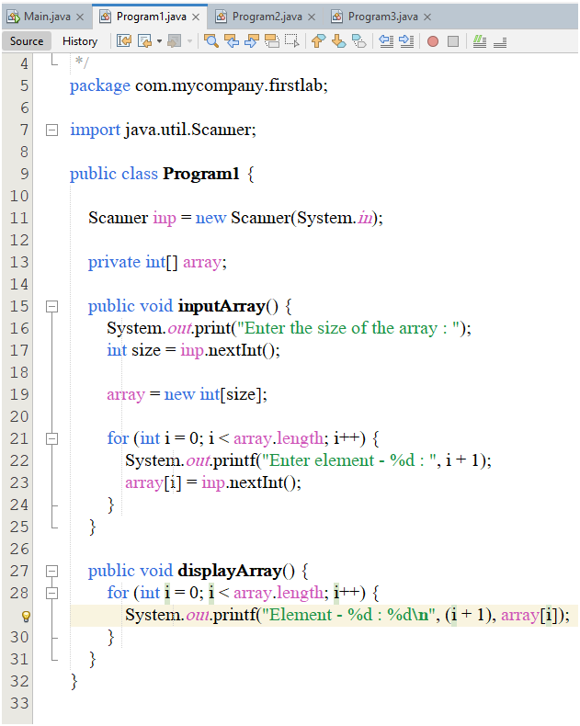

Output:

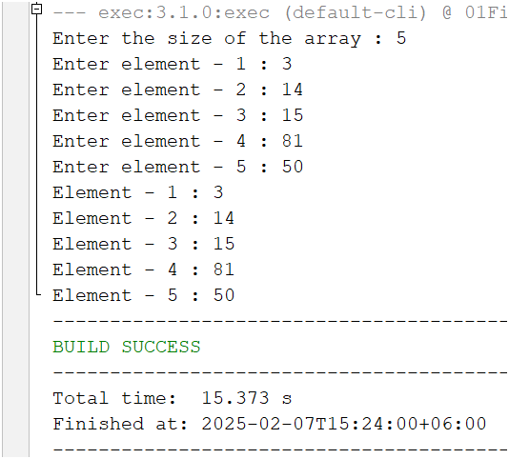

Problem 2: Write a java program that performs string methods like :

i) charAt(); ii) concat(); iii) contains(); iv) equals(); v) indexOf(); vi)isEmpty(); vii) length(); viii) replace(); ix) splits(); x) trim(); xi)toUpperCase(); xii) toLowerCase();

Code:

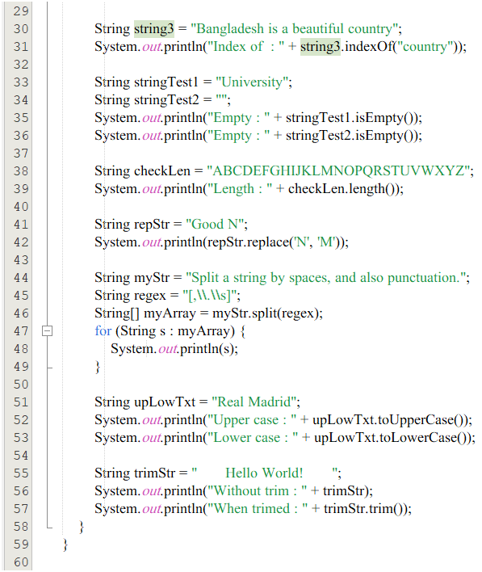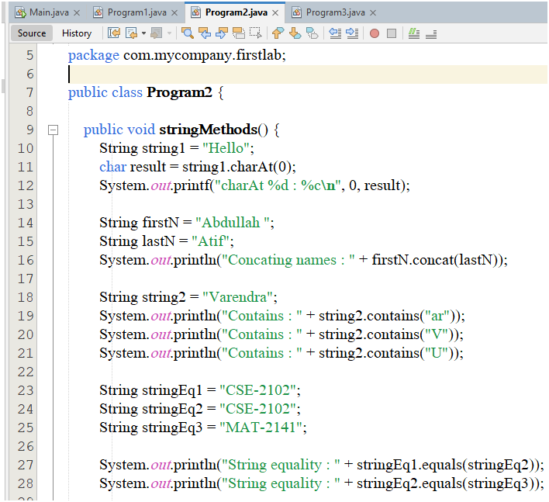

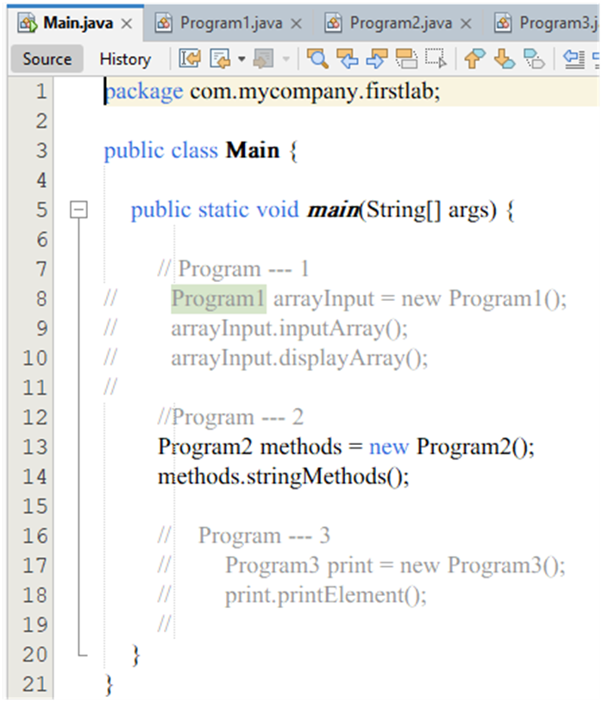

Output:

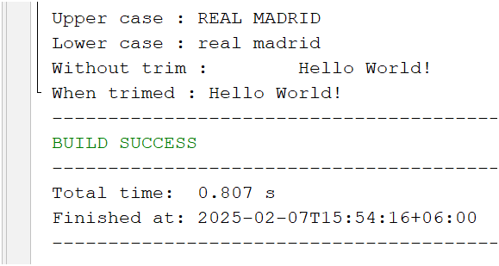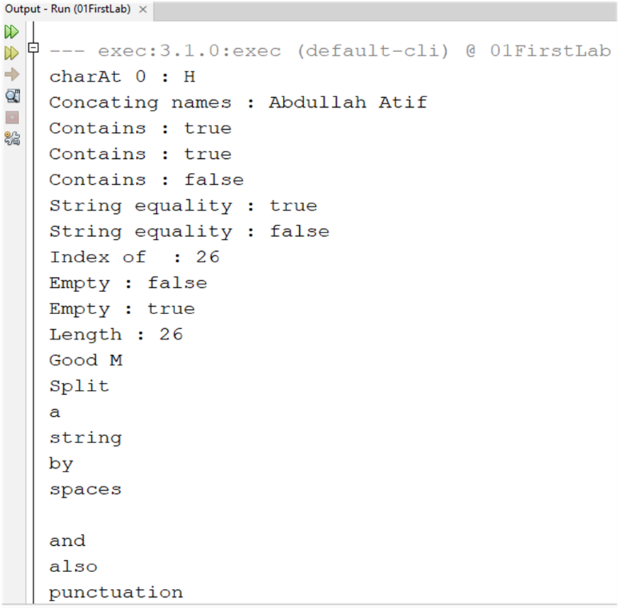

Problem 3: Write a java program to print 1-10 except 5 using continue keyword.

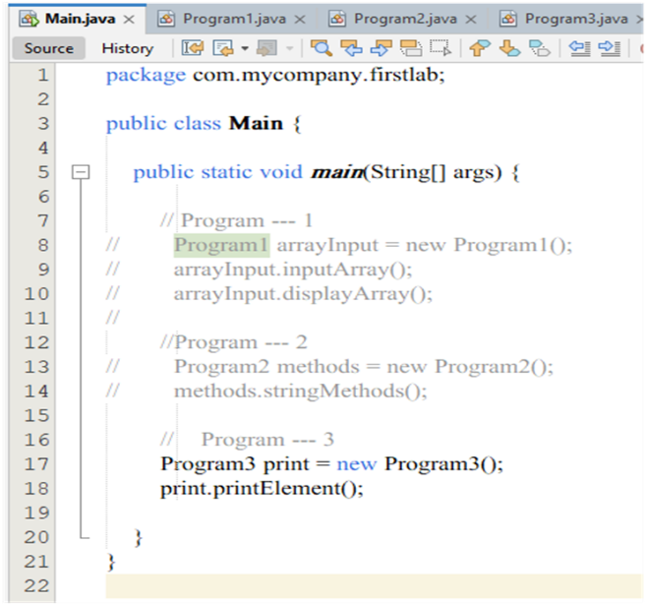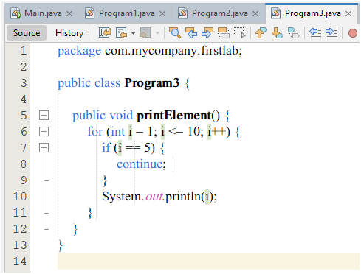Code:

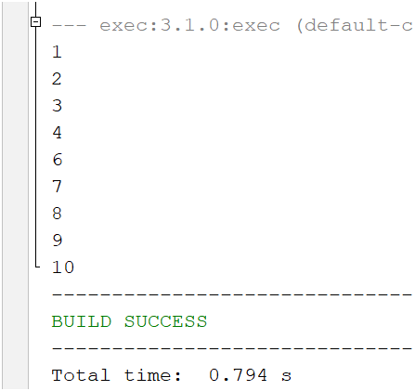Output: